**what is react js ?**

React js is a library of javascript

React js is also called as a framework of javascript

React latest and stable version is 18.0.2 and support ES6

React js is provides SPA single page applications

React js is used to make a website or web applications

React js is used to fast data load on web broswers

React js developed or manage by facebook

React js is based on components and components are reusable.

React js life cycle are components based i.e used to reuse code one page to another page.

React is used import module to import any module one page to another page

React js support a lot of packages that can be reuse or intsall to use.

React js provides to load data without page reload on broswers.

React js is called api or rest api to load url data or invoke api on webpage.

React js is used to load 10x fast data on broswers.

React js provides a large community to solved problems.

React most popular web apps and website is

Ex: facebook, instagrame, whatsapp, Netflix , snapchat, rebook, adidas, amzone, flipkart , twitter, youtube used react as development.

React js provides SEO friendly website.

React js provides life cycle manse flow of data in react js

a) initializations

b) mounting

c) updating

d) unmounting

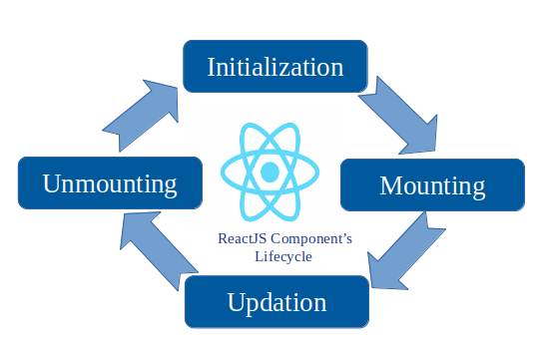

**Advantages of React js :**

React is used to fast load data on web broswers

React js provides reusables components

React js load data calling api and rest api

React js load data without page reload

React js used as frontend but behave just like backed.

React provides large community

React js provides seo friendly web apps or website.

React js is easy to learn.

React js call with virtuals DOM using jsx (javascript extention)

React js is used to make SPA (single page web applications)

React js provides code stability version stability react 18.0.2 stable version

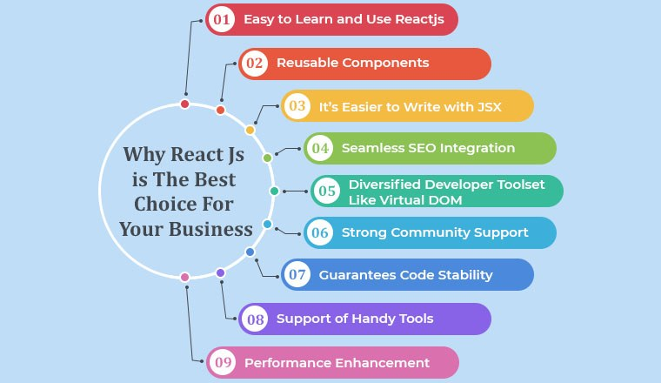

**React js framework or library of javascript how to cerate an app in react js**

**Step 1: we will download node js**

Node js is a used for backend and it is dependency manager to install react or create react js app.

Node modules are help to install all packages in react js app.

<https://nodejs.org/en/download>

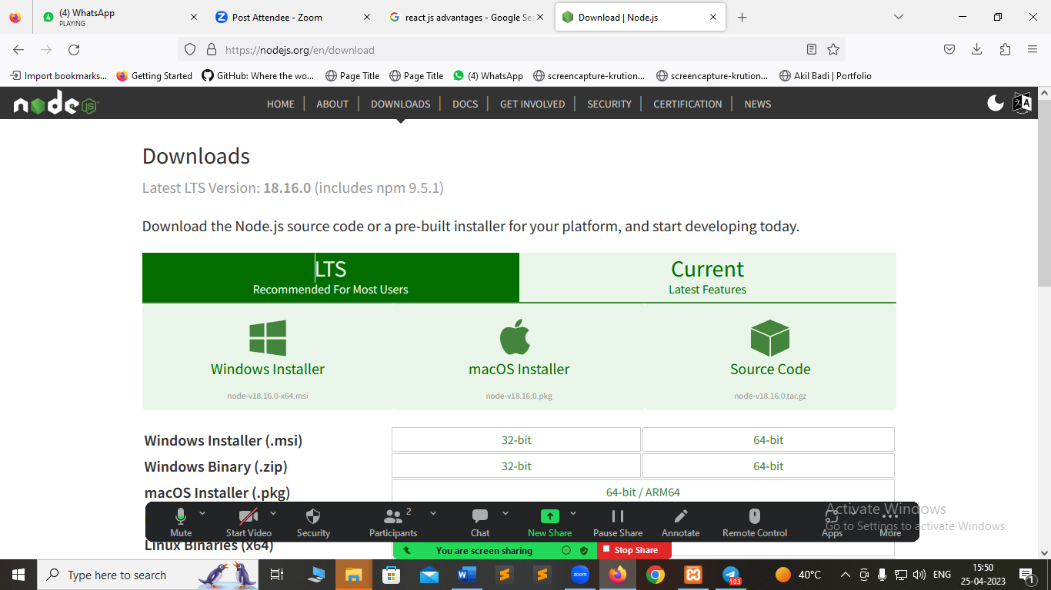

**Step 2: how to check version of node js or intsall or not**

D:\frontend-development\reactjs\module4-reactjs-introduction>node -v

v18.16.0

**step 3: how to check NPM or NPX version**

NPM : npm stands for node package manager this is an dependency manager to help create react js app

How to create react js app using npm

cmd : npm create-react-app app-name

cmd: cd app-name

cmd : npm start

NPX : Npx stands for node package executable it is also install or create react js app

How to create react js app using npx

cmd : npx create-react-app app-name

cmd: cd app-name

cmd : npm start

**Note : appname should be in lower case don’t use uppercase, camel case and don’t start with react keyword.**

**cmd : npx create-react-app myfirst-app**

**cmd: cd myfirst-app**

**cmd: npm start**

**You can now view myfirst-app in the browser.**

**Local:** [**http://localhost:3000**](http://localhost:3000)

**On Your Network:** [**http://192.168.29.4:3000**](http://192.168.29.4:3000)

**Note that the development build is not optimized.**

**To create a production build, use npm run build.**

**webpack compiled successfully**

How to Change React localhost port number

Follow this link

https://stackoverflow.com/questions/50869469/how-to-change-default-localhost-port-for-react-app